**PROJECT REPORT TEMPLATES**

Introduction:

**My Team I’D**-NM2023TMID40054

**My Team Leader**

R. RAJALAKSHMI-B0A9D6E7B949901B2F84079B5ED27EBC

**My Team Members**

R. ARCHANA -C02A803DF58C64CB60A4EA8AE0AE7F93

M. PANDISELVI -6DA051959D768BD828343284CADB7F82

S. KALAISELVI -9EFBCD9BA8F922685AD4AE3AB0175B8F

S. RAMALAKSHMI -60A3C774C19F500B2FC4B989AE21E37F

**My Team Project**

Project name book cover

Me and my team members achieved in a book cover design.

Problem definition &design thinking:

**Empathy map**

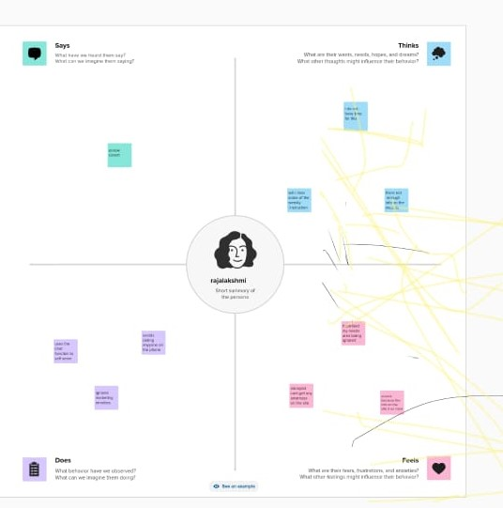

**Brainstorming Map**

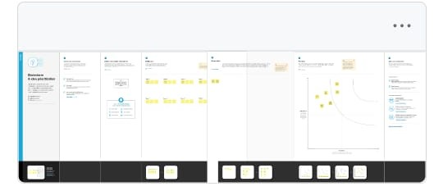

Result:



Advantages:

* + Book cover design simple and unforgettable
  + Communicate with **“RAW”, “EMOTINAL**”, and “**REAL”**

Applications:

* + Search design on canva
  + Then select soul design and change that colour and font

Conclusion:

* These are the things we have done this project.